Relevant Regulations, Laws, Policies, and Processes for Implementation of Product-Focused Incentives
Based on the document, here are the relevant regulations, laws, policies, and processes that would need modification to implement the product-focused incentive concept:
Federal Acquisition Regulation (FAR) Provisions:
- FAR 16.401 - General provisions on incentive contracts
- FAR 16.402-2 - Performance incentives
- FAR 16.405-1 - Cost-plus-incentive-fee contracts
- FAR 34.201 - Policy requirements for Earned Value Management Systems
- FAR 1.102-2(c) - Guiding principles for innovation and creativity
- FAR 1.102-5(e) - Authority to tailor contracting strategies
- FAR 1.102(d) - Economy and efficiency priorities
- FAR 15.304 - Evaluation factors and significant subfactors
- FAR 1.404 - Class deviations
- FAR 1.602-3(b)(2) - Ratification of unauthorized commitments
Defense Federal Acquisition Regulation Supplement (DFARS) Provisions:
- DFARS 216.401 - General provisions on incentive contracts
- DFARS 234.201 - Policy requirements for EVM
- DFARS 252.234-7002 - Earned Value Management System requirements
- DFARS 201.404 - Class deviations
Procedures, Guidance, and Information (PGI):
- PGI 216.401 - Guidance on incentive contracts
Statutory Authorities:
- 41 U.S.C. § 3307 - Preference for commercial products and services
- 41 U.S.C. § 3306(a)(3) - Planning and solicitation requirements
- 40 U.S.C. § 11302 (Clinger-Cohen Act) - Information technology acquisition
- Federal Acquisition Reform Act (FARA)
Standards:
- ANSI/EIA-748 - Earned Value Management Systems standards

Recommended Wording Modifications
FAR 16.401 - Proposed Modifications:
Current wording: Focuses primarily on incentivizing cost control and schedule performance.
Recommended addition (new subsection): "(f) Product-Focused Incentives. (1) Contracting officers may structure incentive fees based primarily on delivered product outcomes and quality metrics that align with mission objectives. (2) Product-focused incentives shall be: (i) Clearly defined with objective, measurable criteria; (ii) Directly related to mission-critical product functionality, quality, or performance; (iii) Independent of or complementary to cost and schedule monitoring; and (iv) Designed to reward contractors for exceeding minimum acceptable product requirements. (3) Award fee payments for product-focused incentives may be disbursed upon product delivery and verification of achievement of specified product metrics."
DFARS 216.401 - Proposed Modifications:
Current wording: Primarily supplements FAR guidance on incentive contracts.
Recommended addition (new subsection): "(e) Product-focused incentives. (1) For major defense acquisition programs, contracting officers shall consider including product-focused incentives that reward: (i) Exceeding key performance parameters; (ii) Enhanced reliability, maintainability, or operational availability; (iii) Reduced lifecycle costs through improved design; and (iv) Innovation that measurably improves mission capability. (2) Product incentive metrics shall be developed in coordination with program management and end-users to ensure alignment with warfighter needs."
FAR 34.201 - Proposed Modifications:
Current wording: Mandates EVM for major acquisitions.
Recommended addition (new subsection): "(c) Waivers or modifications to EVM requirements. (1) Agencies may modify or waive certain EVM reporting requirements when: (i) A comprehensive product-focused incentive structure is implemented that provides equal or greater accountability for mission outcomes; (ii) Simplified cost and schedule tracking methods are maintained as secondary safeguards; and (iii) The acquisition's nature makes product outcomes more relevant to success than process metrics. (2) Such waivers must be documented in the acquisition strategy with justification of how product metrics will ensure accountability."
DFARS 234.201 - Proposed Modifications:
Current wording: Implements EVM policy for defense acquisitions.
Recommended addition (new subsection): "(c) Alternative approaches. (1) Program managers may propose alternative accountability frameworks for major defense acquisition programs that: (i) Emphasize product quality and mission performance over process compliance; (ii) Maintain traceability of expenditures while reducing administrative burden; and (iii) Align profit incentives with operational capabilities and warfighter needs. (2) Such alternatives shall be approved at the Component Acquisition Executive level with documentation of expected benefits and risk mitigation strategies."
PGI 216.401 - Proposed Modifications:
Current wording: Provides guidance on incentive contracts.
Recommended addition: "(e) Product-focused incentives guidance. (1) Recommended approaches for developing product-focused incentives include: (i) Conducting market research to identify industry benchmarks for similar products; (ii) Consulting with end-users to prioritize critical product attributes; (iii) Establishing graduated incentive tiers that reward incremental improvements above threshold requirements; (iv) Implementing independent testing protocols to validate achievement; and (v) Utilizing advanced analytics and AI technologies to objectively assess product quality, safety, and function. (2) Examples of effective product metrics include: [List of domain-specific examples]"
FAR 16.405-1 - Proposed Modifications:
Current wording: Focuses on cost-plus-incentive-fee contracts with emphasis on cost control.
Recommended addition: "(c) Product-focused incentive fees. (1) When appropriate for the acquisition, contracting officers may structure cost-plus-incentive-fee contracts to include separate incentive pools for: (i) Traditional cost control incentives; and (ii) Product quality and performance incentives that are independent of cost performance. (2) The product incentive portion shall be awarded based on delivered outcomes regardless of cost efficiency, provided that costs remain within authorized funding limits."
These modifications would establish the legal framework and implementation guidance necessary to shift from the current EVM-focused approach to the product-focused incentive concept advocated in the document, while maintaining appropriate safeguards and accountability mechanisms.

A Slightly different alternative is this:

Detaching EVM Performance Metrics from Incentive Fees While Maintaining EVM for Reimbursement
Here's how to modify regulations to maintain EVM for cost reimbursement purposes while shifting incentive fees to product outcomes:
FAR 16.401 - Proposed Modifications:
Add new subsection: "(f) Separation of EVM Metrics from Incentive Fee Determinations. (1) For cost-reimbursable contracts requiring Earned Value Management: (i) EVM data shall remain mandatory for cost monitoring, progress reporting, and reimbursement validation purposes; (ii) However, performance incentive fees shall be structured and awarded separately from EVM metrics; (iii) Performance incentive fees shall be tied exclusively to delivered product outcomes, quality, and mission capability. (2) Contract structures shall clearly delineate: (i) EVM requirements for cost monitoring and reimbursement purposes; and (ii) Product-based criteria for determining incentive fee awards. (3) Contractors shall be eligible for full incentive fee potential regardless of EVM variance data, provided that: (i) All cost reimbursements are properly documented and allowable; (ii) The delivered product meets or exceeds specified performance criteria; and (iii) Total costs remain within authorized funding limits."
DFARS 234.201 - Proposed Modifications:
Add new subsection: "(e) Dual-purpose EVM implementation. (1) For contracts requiring EVM systems under this subpart: (i) EVM data shall be used for cost reimbursement validation and progress monitoring; (ii) EVM metrics shall not directly impact award or incentive fee determinations; and (iii) Contract provisions shall explicitly separate reimbursement processes from incentive fee evaluations. (2) Contracting officers shall ensure that: (i) Cost reimbursement determinations utilize EVM data to validate allowable costs; (ii) Incentive fee provisions reference only product delivery metrics; and (iii) Contract language prevents penalizing contractors for EVM variances when delivered products exceed specified requirements."
FAR 16.405-2 - Cost-Plus-Award-Fee Contracts:
Add new paragraph: "(d) Product-focused award fees. (1) When implementing EVM requirements on cost-plus-award-fee contracts: (i) Award fee plans shall specify that fee determinations are based exclusively on delivered product outcomes; (ii) EVM data shall be used only for cost surveillance and reimbursement purposes; and (iii) Award fee evaluations shall document how product performance influenced fee determinations independent of EVM metrics. (2) Award fee evaluation criteria shall focus on measurable product attributes including but not limited to: (i) Functionality; (ii) Quality; (iii) Reliability; (iv) Interoperability; and (v) User satisfaction."
PGI 216.401 - Proposed Guidance Addition:
Add new section: "(f) Implementation guidance for separated EVM and incentive structures. (1) Contract language examples: (i) 'While the Contractor is required to maintain an EVMS compliant with ANSI/EIA-748 for cost reporting and reimbursement purposes, incentive fee determinations shall be based solely on delivered product performance criteria specified in Attachment X.' (ii) 'The Government will utilize EVM data to validate costs for reimbursement. However, the award fee determination will be based exclusively on the product performance evaluation criteria in the Award Fee Plan.' (2) Recommended contractual structure: (i) Include separate contract sections for EVM requirements and incentive fee criteria; (ii) Explicitly state that negative EVM variances will not reduce incentive fees if product criteria are met; (iii) Structure payment timing so that reimbursable costs are paid on regular intervals based on EVM validation, while incentive fees are paid upon product delivery and verification of performance metrics. (3) Practical implementation approaches: (i) Maintain monthly EVM reporting for cost monitoring; (ii) Conduct quarterly program management reviews using EVM data for schedule and cost discussions; (iii) Reserve incentive fee discussions and determinations for separate product-focused reviews upon delivery milestones; (iv) Document incentive fee decisions with specific reference to product outcomes and verification results."
This approach maintains the cost-control benefits of EVM for reimbursement validation while completely separating the incentive structure to focus exclusively on product outcomes. It creates a clean division where EVM serves its administrative function for cost management while contractors' profit incentives align purely with delivering superior products.

Visual Image of the Concept and Alignment:

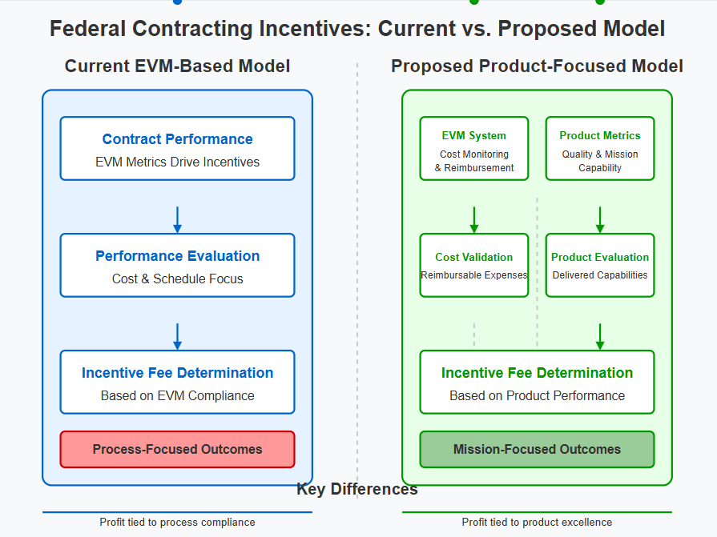

Current vs. Proposed Federal Contracting Incentives
Based on your request, I've created a visual comparison that illustrates the fundamental differences between the current EVM-based incentive model and the proposed product-focused incentive approach.
Key Differences Highlighted in the Visual:
Current EVM-Based Model (Left Side):
- Single Flow: All aspects of the contract (performance monitoring, evaluation, and incentive determination) are tied to EVM metrics
- Process-Centric: Incentives primarily reward adherence to cost and schedule plans
- Entangled Metrics: No separation between cost monitoring and profit incentives
- Outcome: Tends to produce process-focused results that may not align with mission needs
Proposed Product-Focused Model (Right Side):
- Dual Tracks: Separates cost monitoring/reimbursement from incentive determination
- EVM Maintained: Still uses EVM for cost validation and reimbursement purposes
- Detached Incentives: Profit determination follows a separate evaluation path based solely on product performance
- Clear Division: Visual separation between the administrative function (left) and the incentive function (right)
- Outcome: Produces mission-focused results that better align with government objectives
The visual emphasizes how the proposed model maintains EVM for its appropriate administrative function (cost monitoring and reimbursement validation) while creating a separate pathway for determining incentive fees based on product quality, performance, and mission capability.

