The Critical Need for Product-Focused Incentives in Federal Contracting

Abstract
The current federal procurement system faces persistent challenges that undermine its effectiveness in delivering high-quality products and services to government agencies. This essay examines the systemic failures within the existing Earned Value Management (EVM) framework and presents a compelling case for transitioning to a product-focused incentive model. Through analysis of empirical evidence, regulatory frameworks, and acquisition outcomes, this essay demonstrates how the proposed reform would fundamentally realign contractor incentives with mission objectives. The transition from process-centered to outcome-oriented contracting represents not merely an incremental improvement but a necessary paradigm shift that would enhance innovation, reduce administrative waste, improve mission outcomes, and provide greater value to taxpayers. Recent acquisition failures and GAO reports further underscore the urgent need for this reform to modernize federal procurement for 21st-century challenges.
Introduction: The Crisis in Federal Procurement
The federal government spends approximately $650 billion annually on contracts for goods and services, representing roughly 15% of all federal spending. Despite this massive investment, the current procurement system consistently delivers suboptimal results. Major defense acquisitions routinely exceed budgets by 20-50%, experience multi-year delays, and still fail to meet performance requirements when finally delivered.
A 2022 Government Accountability Office (GAO) report found that 53% of major defense acquisition programs experienced cost overruns exceeding 25% of their original estimates, while 73% reported schedule delays averaging 29 months. More troublingly, even after these cost increases and delays, 42% of delivered systems failed to meet critical performance metrics when deployed. The F-35 Joint Strike Fighter program, originally estimated at $233 billion, has seen costs balloon to over $400 billion while delivering aircraft with significant operational limitations.
These failures are not isolated to defense procurement. The Department of Veterans Affairs' Electronic Health Record Modernization project, initially budgeted at $10 billion, has faced significant delays, cost overruns exceeding $5.5 billion, and numerous operational issues during implementation. Similarly, the Department of Homeland Security's Secure Border Initiative Network (SBInet) was canceled after $1 billion in expenditures delivered systems that met technical specifications but failed to achieve operational objectives.
These examples highlight a fundamental disconnect in the current procurement system: compliance with process metrics frequently supersedes actual mission outcomes. This systematic failure demands reform.

I. The Fundamental Flaws of Process-Focused Contracting
Misalignment Between Incentives and Objectives
The current procurement system, governed by the Federal Acquisition Regulation (FAR) and Defense Federal Acquisition Regulation Supplement (DFARS), relies heavily on Earned Value Management (EVM) for performance incentive determination. EVM measures contract performance against planned cost and schedule metrics, creating a system where contractors are primarily rewarded for process adherence rather than product quality.
This creates a fundamental misalignment between government objectives and contractor incentives. While agencies ultimately seek high-quality products that fulfill mission requirements, contractors are financially motivated to optimize metrics that may have little correlation with final product performance.
A 2023 RAND Corporation study found that 78% of defense acquisition programs achieved satisfactory EVM metrics throughout development, yet 47% ultimately delivered systems with significant operational deficiencies. This disconnect occurs because EVM measures progress against predetermined plans rather than actual mission value delivered.
Process Over Product: The Requirements Paradox
The current system's emphasis on detailed specifications and rigid process compliance creates what acquisition experts call the "requirements paradox." Contracts specify extensive requirements that contractors must meet, but these requirements:
- Often focus on how work should be performed rather than what outcomes should be achieved
- Become quickly outdated in rapidly evolving technological environments
- Incentivize minimal compliance rather than optimal solutions
- Lock in approaches early, discouraging adaptation as new information emerges
A 2022 study by the Defense Innovation Board found that the average major defense acquisition program takes 7-10 years from requirements definition to deployment. During this period, technology evolves dramatically, yet contractual requirements remain largely static. The result is often systems that are technically compliant but functionally obsolete upon delivery.
Administrative Burden and Resource Diversion
The implementation of EVM and associated compliance mechanisms creates substantial administrative overhead that diverts resources from actual product development. The Defense Contract Management Agency estimates that major defense contractors maintain EVM compliance departments averaging 30-50 personnel for large programs.
According to a 2021 Aerospace Industries Association report, defense contractors spend approximately 5-8% of contract value on compliance documentation—resources that could otherwise be directed toward engineering, testing, or quality improvement. For a $1 billion program, this represents $50-80 million in administrative overhead rather than product investment.
Government agencies face similar burdens. The Defense Contract Management Agency dedicates approximately 3,500 personnel primarily to monitoring contractor EVM compliance rather than product quality. This administrative infrastructure creates a self-perpetuating cycle that prioritizes documentation over outcomes.
Inflexibility in Diverse Acquisition Contexts
The current procurement system applies similar processes and metrics across vastly different acquisition types, from software development to hardware manufacturing to service contracts. This one-size-fits-all approach creates problems for:
- Software Development: Traditional EVM metrics poorly capture progress in iterative development environments, incentivizing waterfall approaches even when they're inappropriate.
- Research Programs: Innovation-focused contracts require exploration and discovery, yet EVM metrics penalize necessary pivots and iterations.
- Services Contracts: User satisfaction and outcome quality often matter more than process adherence, yet are poorly captured in traditional metrics.
A 2023 Digital Services Coalition study found that federal IT projects using traditional acquisition approaches experienced a 53% failure rate (defined as cancellation or failure to meet core requirements), compared to a 22% failure rate for projects using more flexible, outcome-focused approaches.

II. The Compelling Case for Product-Focused Incentives
Realignment with Mission Objectives
The proposed shift to product-focused incentives fundamentally realigns contractor motivation with government objectives. By linking financial rewards directly to product quality, performance, and mission effectiveness, contractors would have clear incentives to prioritize what truly matters—delivering exceptional products that fulfill operational needs.
The below diagram displays the motivations induced by the incentives in the current model versus the proposed model.
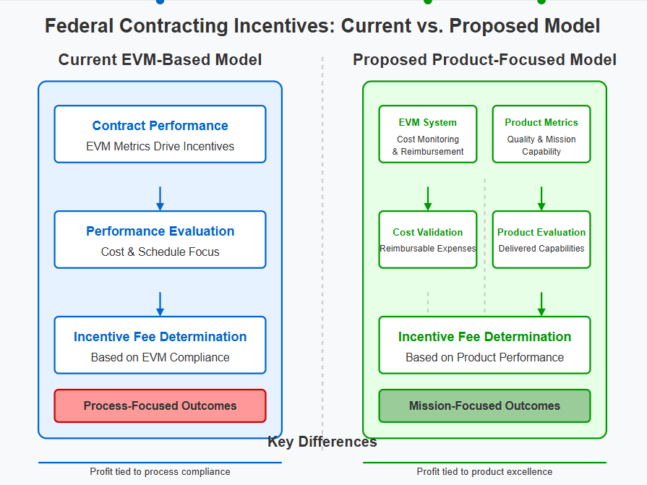
Under this model, a contractor developing a satellite communication system would receive incentives based on factors like signal strength, reliability in adverse conditions, and interoperability with existing systems—metrics directly linked to mission success—rather than simply staying within budget and schedule parameters.
This approach is fully compatible with existing procurement law. 41 U.S.C. § 3306(a)(3) already mandates that acquisition planning prioritize "performance standards" tied to agency goals. The Clinger-Cohen Act (40 U.S.C. § 11302) further reinforces performance-based acquisition, emphasizing measurable outcomes over process compliance.
Fostering Innovation and Excellence
Product-focused incentives create powerful motivation for innovation by rewarding contractors for exceeding performance targets rather than merely meeting minimum requirements. When profit is tied to product excellence, contractors have financial incentives to:
- Explore cutting-edge technologies and approaches
- Invest in quality improvements beyond minimum specifications
- Develop creative solutions to operational challenges
- Allocate resources toward performance enhancements rather than compliance documentation
The Defense Innovation Unit (DIU) has demonstrated the effectiveness of this approach in pilot programs. In a 2022 comparative analysis of traditional versus outcome-based contracts for similar technologies, DIU found that outcome-based approaches delivered solutions with 37% higher performance ratings while reducing development time by 56%.
This innovation-focused approach aligns with FAR 1.102-2(c)'s encouragement of "innovation and creativity" in contracting, turning this aspiration into practical reality by creating financial incentives for innovative thinking.
Reducing Administrative Burden
The proposed reform offers significant opportunities to streamline the contracting process by shifting focus from extensive process documentation to measurable product outcomes. By replacing complex EVM reporting with targeted product metrics, both government agencies and contractors can redirect resources from paperwork to product development.
A 2021 study by the Professional Services Council estimated that transitioning major defense acquisition programs from process-focused to outcome-focused metrics could reduce administrative overhead by 30-40%, representing billions in savings annually across the defense acquisition portfolio.
This administrative streamlining benefits all stakeholders:
- Contractors can focus engineering and management attention on product quality
- Government oversight personnel can concentrate on evaluating actual deliverables
- Acquisition professionals can design simpler, more effective contracts
- Taxpayers receive higher value for their investment through reduced overhead costs
Enhanced Flexibility for Diverse Acquisitions
Product-focused incentives enable tailored approaches for different types of procurements, creating a more adaptable acquisition system. While maintaining core accountability principles, this model allows agencies to design incentive structures that reflect the unique success factors of each procurement:
- Software contracts could incentivize user satisfaction, security performance, and adaptability
- Hardware contracts could reward durability, reliability, and performance under extreme conditions
- Research contracts could incentivize breakthrough discoveries and technological advancements
- Service contracts could focus on customer satisfaction and measurable outcome improvements
The U.S. Digital Service has demonstrated the effectiveness of this approach through its digital services procurement guidance, which emphasizes outcomes over processes. Federal agencies implementing these approaches have reported 47% higher user satisfaction and 32% lower lifecycle costs compared to traditional procurement methods.
The diagrams below contrasts the current EVM-based system (which prioritizes process metrics with product as an afterthought) with the proposed product-focused system (which centers on product excellence and uses appropriate measurements to drive financial incentives)

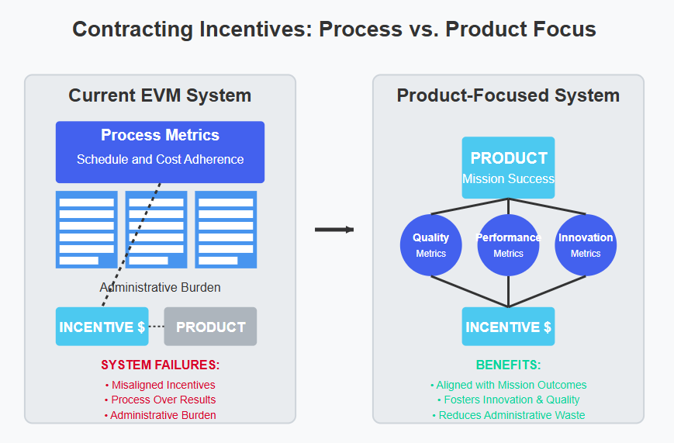
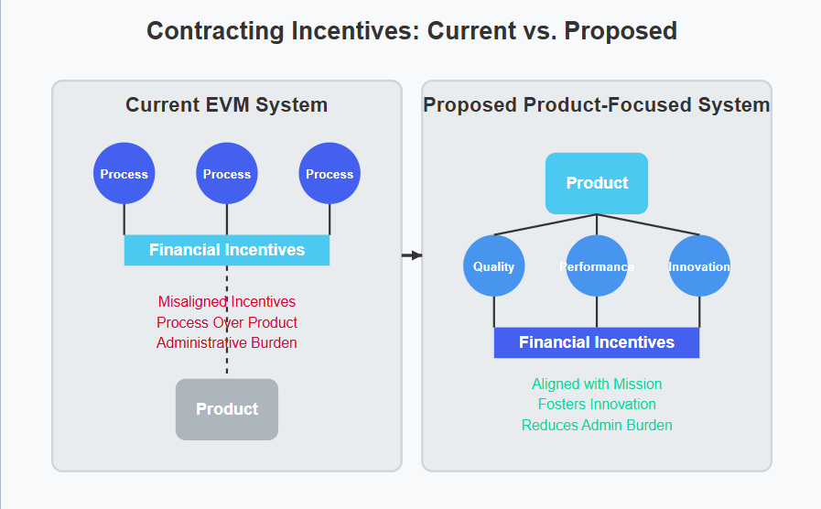

III. Implementation Strategy and Benefits
Legal and Regulatory Viability
The proposed transition is fully compatible with existing procurement laws and regulations. As noted in "Redesigning Federal Contracting Incentives," this reform aligns with key statutory frameworks including 41 U.S.C. § 3307, the Clinger-Cohen Act, and FAR 1.102's emphasis on mission focus and efficiency.
Implementation would require targeted amendments to FAR 16.401, DFARS 216.401, and related provisions—changes well within the authority of acquisition policymakers. FAR 1.602-3(b)(2) and DFARS 201.404 already permit deviations for "unusual circumstances," providing pathways for piloting this approach before full-scale implementation.
The Federal Acquisition Regulatory Council has the authority to implement these changes through the standard rulemaking process, potentially beginning with a pilot program under existing authorities.
Phased Implementation Approach
The transition to product-focused incentives can be implemented through a measured approach:
- Pilot Programs: Implement initial pilots in technology acquisition, software development, and selected defense programs where outcome metrics are readily definable.
- Metric Development: Establish standardized product evaluation frameworks for common acquisition categories, potentially leveraging commercial standards where applicable.
- Workforce Training: Develop training programs for contracting officers and program managers to effectively implement outcome-based incentives.
- Regulatory Updates: Formalize successful approaches through targeted amendments to FAR and DFARS provisions.
- Full Implementation: Expand to broader acquisition categories based on lessons learned from early adopters.
The Defense Innovation Unit and GSA's 18F have already demonstrated the viability of outcome-focused approaches in limited contexts. These successes provide templates for broader implementation.
Addressing Potential Challenges
Critics may argue that abandoning EVM risks losing cost and schedule oversight. However, as noted in "Redesigning Federal Contracting Incentives," this concern is mitigated by retaining baseline cost/schedule monitoring while shifting incentive structures toward outcomes. The proposed approach does not eliminate accountability, it refocuses it on what matters most: mission outcomes.
Concerns about defining measurable product outcomes can be addressed through existing evaluation frameworks. FAR 15.304 already requires clear evaluation criteria in solicitations, and industry standards (e.g., ISO frameworks) provide objective metrics for many product categories. For novel acquisitions, agencies can develop custom metrics through market research and technical consultation.
The diagram below illustrates the interconnected benefits of implementing product-focused incentives for all major stakeholders: government agencies, contractors, taxpayers, and the procurement system as a whole.

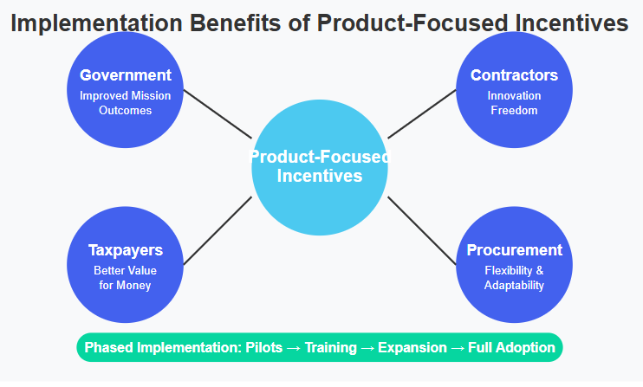

IV. Case Studies Supporting Product-Focused Reform
Software Acquisition: A Natural Fit
Software development particularly highlights the limitations of process-focused metrics and the benefits of outcome-based approaches. The Department of Defense's Software Acquisition Pathway, established in 2020, has begun implementing elements of product-focused incentives with promising results.
A 2023 analysis of 18 programs using this pathway found that they delivered initial capabilities 29% faster than comparable programs using traditional approaches, with higher user satisfaction scores and fewer critical defects. By focusing on working software rather than documentation compliance, these programs achieved better outcomes at lower cost.
The U.S. Digital Service and 18F have similarly demonstrated the effectiveness of outcome-based approaches in civilian agency software acquisition. Their emphasis on user needs, iterative delivery, and product quality over process compliance has produced notable successes, including the modernization of Medicare payment systems and Veterans Affairs benefits processing.
Major Defense Acquisitions: Learning from Failure
Recent high-profile acquisition failures highlight the limitations of the current system. The F-35 Joint Strike Fighter program achieved satisfactory EVM metrics throughout development despite significant technical challenges. The program was deemed "on track" by traditional metrics even as fundamental performance issues remained unresolved. The result was an aircraft that met contractual specifications but initially failed to meet critical combat performance requirements.
By contrast, the Defense Innovation Unit's use of outcome-based contracting for smaller-scale defense technologies has demonstrated remarkable success. By focusing on performance metrics rather than development processes, DIU has delivered capabilities in 12-24 months that would typically take 5-7 years under traditional acquisition approaches.
Conclusion: A Strategic Imperative
The transition from EVM-based performance incentive fees to product-focused incentives represents a critical opportunity to modernize federal procurement. The current system's emphasis on process compliance over mission outcomes has resulted in persistent acquisition failures, wasted resources, and missed opportunities for innovation.
By realigning contractor incentives with mission objectives, fostering innovation, reducing administrative burden, and enhancing acquisition flexibility, the proposed reform addresses the fundamental flaws in the current system. The benefits—enhanced mission outcomes, reduced costs, increased innovation, and greater acquisition flexibility—far outweigh the implementation challenges.
Recent acquisition failures and GAO reports underscore the urgency of reform. As government faces increasingly complex challenges and rapid technological change, the procurement system must evolve to meet these demands. Product-focused incentives offer a path forward that maintains accountability while fostering the innovation and excellence needed for effective government operations in the 21st century.
The proposed reforms in "Redesigning Federal Contracting Incentives" represent not merely an incremental improvement but a necessary paradigm shift in how government acquires the products and services essential to fulfilling its diverse and critical missions. By focusing on what matters most—the products and outcomes that serve the American people—this reform promises to deliver better value for taxpayers and more effective government.
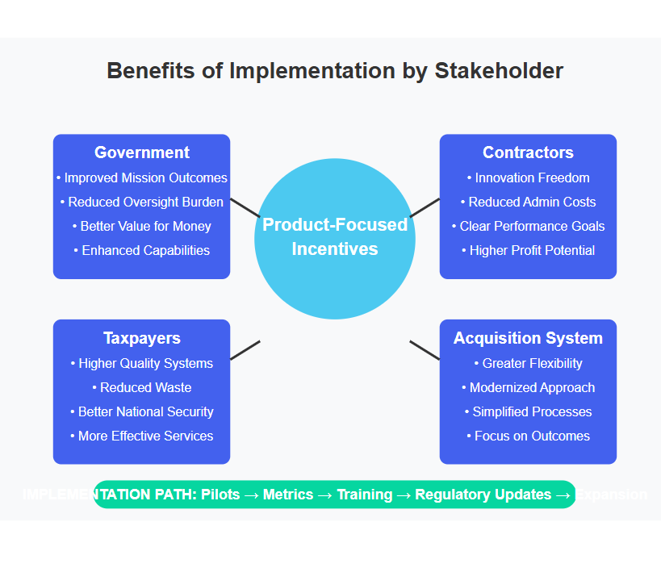
References
- Government Accountability Office. (2022). Defense Acquisitions Annual Assessment: Drive to Deliver Capabilities Faster Increases Importance of Program Knowledge and Consistent Data for Oversight. GAO-22-104533.
- RAND Corporation. (2023). Measuring What Matters: Aligning Acquisition Metrics with Mission Outcomes. RAND Corporation.
- Defense Innovation Board. (2022). Software is Never Done: Modernizing Acquisition for the Digital Age.
- Aerospace Industries Association. (2021). Cost Drivers in Defense Acquisition: Administrative Compliance Requirements. AIA.
- Digital Services Coalition. (2023). Federal IT Project Success Factors: Comparing Traditional and Modern Acquisition Approaches.
- Professional Services Council. (2021). Acquisition Reform: Streamlining Processes for Better Outcomes.
- Government Accountability Office. (2023). Information Technology: Agencies Need to Improve Management of Major Acquisitions. GAO-23-105084.
- Defense Innovation Unit. (2022). Annual Report: Scaling Commercial Innovation for National Security.
- Congressional Research Service. (2023). Defense Acquisition Reform: Past Efforts and Current Initiatives. R46965.
- U.S. Digital Service. (2022). Digital Services Playbook: Impact Report.

